**What is Python programming language?**

Python is a **high-level, general-purpose, interpreted**programming language.

**1) High-level**

Python is a high-level programming language that makes it easy to learn. Python doesn’t require you to understand the details of the computer in order to develop programs efficiently.

**2) General-purpose**

Python is a general-purpose language. It means that you can use Python in various domains including:

* Web applications
* Big data applications
* Testing
* Automation
* Data science, machine learning, and AI
* Desktop software
* Mobile apps

The targeted language like SQL which can be used for querying data from relational databases.

**3) Interpreted**

Python is an interpreted language. To develop a Python program, you write Python code into a file called source code.

To execute the source code, you need to convert it to the machine language that the computer can understand. And the Python **interpreter**turns the source code, line by line, once at a time, into the machine code when the Python program executes.

Compiled languages like Java and C# use a **compiler**that compiles the whole source code before the program executes.

**Why Python**

Python increases your productivity. Python allows you to solve complex problems in less time and fewer lines of code. It’s quick to make a prototype in Python.

Python becomes a solution in many areas across industries, from web applications to data science and machine learning.

Python is quite easy to learn in comparison with other programming languages. Python syntax is clear and beautiful.

Python has a large ecosystem that includes lots of libraries and frameworks.

Python is cross-platform. Python programs can run on Windows, Linux, and macOS.

Python has a huge community. Whenever you get stuck, you can get help from an active community.

Python developers are in high demand.

**History of Python**

* Python was created by Guido Van Rossum.
* The design began in the late 1980s and was first released in February 1991.

**Why the name Python?**

No. It wasn't named after a dangerous snake. Rossum was fan of a comedy series from late 70s. The name "Python" was adopted from the same series "Monty Python's Flying Circus".

**Python Version History**

Implementation started - December 1989

Internal releases – 1990

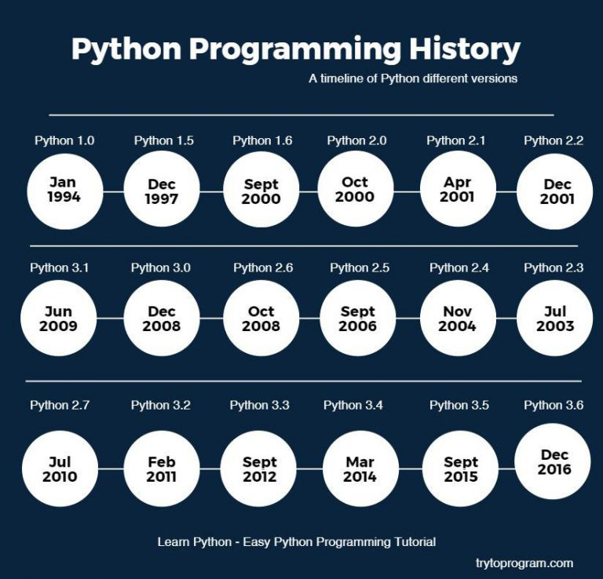

**Install Python on Windows**

First, [download the latest version of Python](https://www.python.org/downloads/) from the download page.

Second, double-click the installer file to launch the setup wizard.

In the setup window, you need to check the **Add Python 3.8 to PATH**and click Install Now to begin the installation.

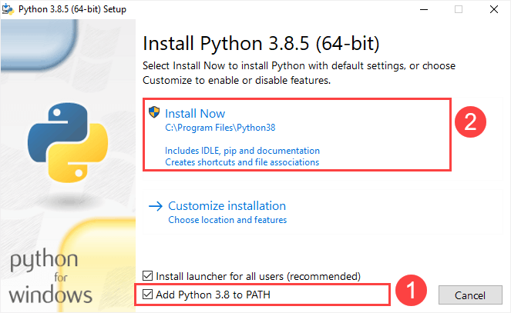

It’ll take a few minutes to complete the setup.

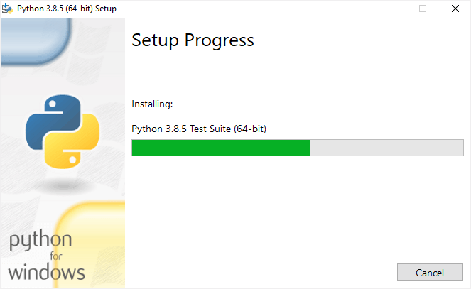

Once the setup completes, you’ll see the following window:

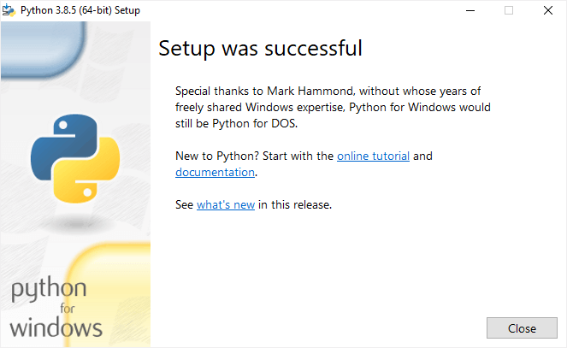

**Verify the installation**

To verify the installation, you open the Run window and type cmd and press Enter:

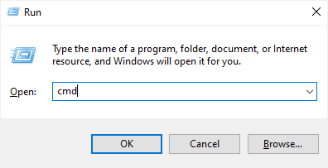

In the Command Prompt, type python command as follows:

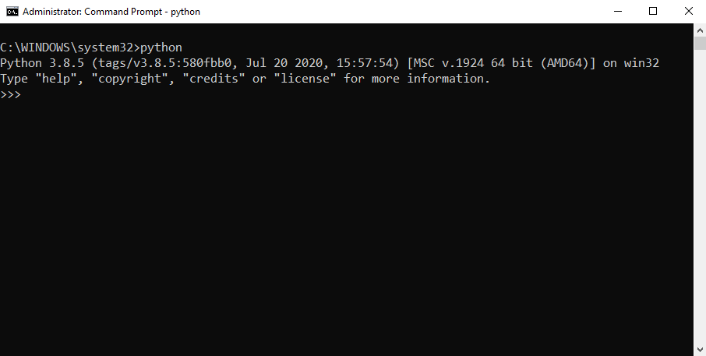

If you see the output like the above screenshot, you’ve successfully installed Python on your computer.

To exit the program, you type Ctrl-Z and press Enter.

If you see the following output from the Command Prompt after typing the python command:

'python' is not recognized as an internal or external command,

operable program or batch file.

Likely, you didn’t check the **Add Python 3.8 to PATH** checkbox when you install Python.

**Install Python on macOS**

It’s recommended to install Python on macOS using an official installer. Here are the steps:

* First, [download a Python release for macOS](https://www.python.org/downloads/macos/).
* Second, run the installer by double-clicking the installer file.
* Third, follow the instruction on the screen and click the Next button until the installer completes.

**Install Python on Linux**

Before installing Python 3 on your Linux distribution, you check whether Python 3 was already installed by running the following command from the terminal:

python3 --version

If you see a response with the version of Python, then your computer already has Python 3 installed. Otherwise, you can install Python 3 using a package management system.

For example, you can install Python 3.10 on Ubuntu using apt:

sudo apt install python3.10

To install the newer version, you replace 3.10 with that version.

A quick introduction to the Visual Studio Code

Visual Studio Code is a lightweight source code editor. The Visual Studio Code is often called VS Code. The VS Code runs on your desktop. It’s available for Windows, macOS, and Linux.

VS Code comes with many features such as IntelliSense, code editing, and extensions that allow you to edit Python source code effectively. The best part is that the VS Code is open-source and free.

Besides the desktop version, [VS Code also has a browser version](https://vscode.dev/) that you can use directly in your web browser without installing it.

This tutorial teaches you how to set up Visual Studio Code for a Python environment so that you can edit, run, and debug Python code.

Setting up Visual Studio Code

To set up the VS Code, you follow these steps:

First, navigate to the [VS Code official](https://code.visualstudio.com/) website and download the VS code based on your platform (Windows, macOS, or Linux).

Second, launch the setup wizard and follow the steps.

Once the installation completes, you can launch the VS code application:

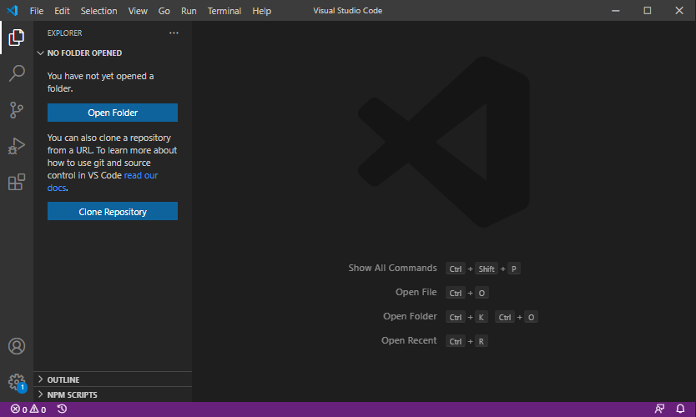

**Install Python Extension**

To make the VS Code works with Python, you need to install the Python extension from the Visual Studio Marketplace.

The following picture illustrates the steps:

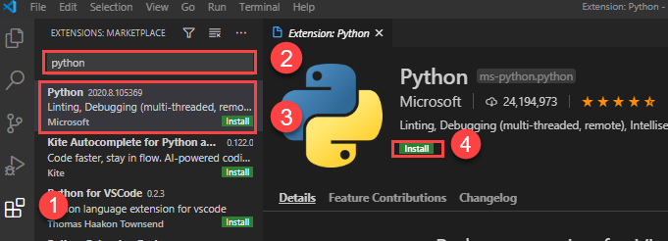

* First, click the **Extensions** tab.
* Second, type the python extension pack keyword on the search input.
* Third, click the Python extension pack. It’ll show detailed information on the right pane.
* Finally, click the **Install** button to install the Python extension.

Now, you’re ready to develop the first program in Python.

Creating a new Python project

First, create a new folder called helloworld.

Second, launch the VS code and open the helloworld folder.

Third, create a new app.py file and enter the following code and save the file:

print('Hello, World!')

Code language: Python (python)

The print() is a built-in function that displays a message on the screen. In this example, it’ll show the message 'Hello, Word!'.

What is a function

When you sum two numbers, that’s a function. And when you multiply two numbers, that’s also a function.

Each function takes your inputs, applies some rules, and returns a result.

In the above example, the print() is a function. It accepts a string and shows it on the screen.

Python has many built-in functions like the print() function to use them out of the box in your program.

In addition, Python allows you to define your functions, which you’ll learn how to do it later.

Executing the Python Hello World program

To execute the app.py file, you first launch the Command Prompt on Windows or Terminal on macOS or Linux.

Then, navigate to the helloworld folder.

After that, type the following command to execute the app.py file:

python app.py

Code language: Python (python)

If you use macOS or Linux, you use python3 command instead:

python3 app.py

Code language: CSS (css)

If everything is fine, you’ll see the following message on the screen:

Hello, World!

Code language: Python (python)

If you use VS Code, you can also launch the Terminal within the VS code by:

* Accessing the menu **Terminal > New Terminal**
* Or using the keyboard shortcut Ctrl+Shift+`.

Typically, the backtick key (`) locates under the Esc key on the keyboard.

Python IDLE

Python IDLE is the Python Integration Development Environment (IDE) that comes with the Python distribution by default.

The Python IDLE is also known as an interactive interpreter. It has many features such as:

* Code editing with syntax highlighting
* Smart indenting
* And auto-completion

In short, the Python IDLE helps you experiment with Python quickly in a trial-and-error manner.

The following shows you step by step how to launch the Python IDLE and use it to execute the Python code:

First, launch the Python IDLE program:

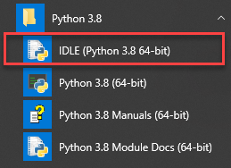

A new Python Shell window will display as follows:

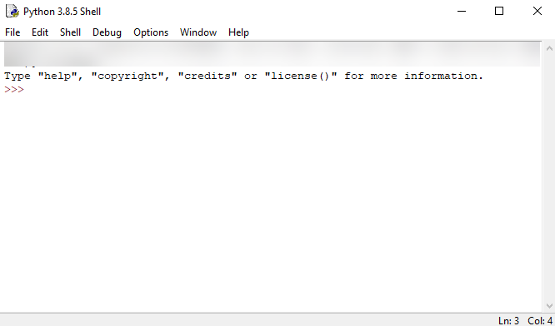

Now, you can enter the Python code after the cursor >>> and press Enter to execute it.

For example, you can type the code print('Hello, World!') and press Enter, you’ll see the message Hello, World! immediately on the screen:

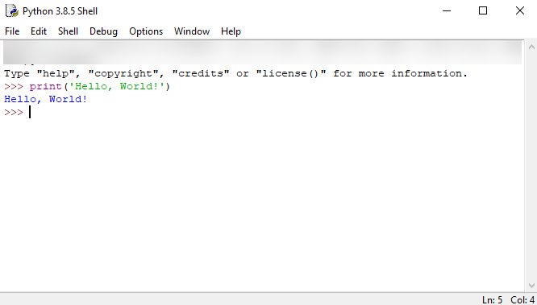

**Python Syntax**

## Whitespace and indentation

If you’ve been working in other programming languages such as Java, C#, or C/C++, you know that these languages use semicolons (;) to separate the statements.

However, Python uses whitespace and indentation to construct the code structure.

The following shows a snippet of Python code:

*# define main function to print out something*

def main():

i = 1

max = 10

while (i < max):

print(i)

i = i + 1

*# call function main*

main()

The meaning of the code isn’t important to you now. Please pay attention to the code structure instead.

At the end of each line, you don’t see any semicolon to terminate the statement. And the code uses indentation to format the code.

By using indentation and whitespace to organize the code, Python code gains the following advantages:

* First, you’ll never miss the beginning or ending code of a block like in other programming languages such as Java or C#.
* Second, the coding style is essentially uniform. If you have to maintain another developer’s code, that code looks the same as yours.
* Third, the code is more readable and clearer in comparison with other programming languages.

## Comments

The comments are as important as the code because they describe why a piece of code was written.

When the Python interpreter executes the code, it ignores the comments.

In Python, a single-line comment begins with a hash (#) symbol followed by the comment. For example:

*# This is a single line comment in Python*

## Continuation of statements

Python uses a newline character to separate statements. It places each statement on one line.

However, a long statement can span multiple lines by using the backslash (\) character.

The following example illustrates how to use the backslash (\) character to continue a statement in the second line:

if (a == True) and (b == False) and \

(c == True):

print("Continuation of statements")

## Identifiers

Identifiers are names that identify variables, functions, modules, classes, and other objects in Python.

The name of an identifier needs to begin with a letter or underscore (_). The following characters can be alphanumeric or underscore.

Python identifiers are case-sensitive. For example, the counter and Counter are different identifiers.

In addition, you cannot use Python keywords for naming identifiers.

## Keywords

Some words have special meanings in Python. They are called keywords.

The following shows the list of keywords in Python:

False class finally is return

None continue for lambda try

True def from nonlocal while

and del global not with

as elif if or yield

assert else import pass

break except in raise

Python is a growing and evolving language. So, its keywords will keep increasing and changing.

Python provides a special module for listing its keywords called keyword.

To find the current keyword list, you use the following code:

import keyword

print(keyword.kwlist)

## String literals

Python uses single quotes ('), double quotes ("), triple single quotes (''') and triple-double quotes (""") to denote a string literal.

The string literal need to be surrounded with the same type of quotes. For example, if you use a single quote to start a string literal, you need to use the same single quote to end it.

The following shows some examples of string literals:

s = 'This is a string'

print(s)

s = "Another string using double quotes"

print(s)

s = ''' string can span

multiple line '''

print(s)